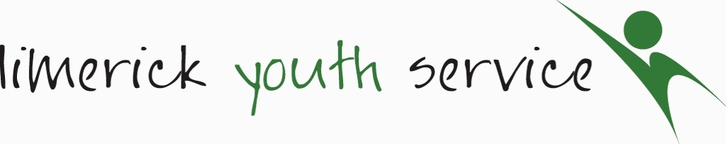

5 Lower Glentworth Street, Limerick.

Child Safeguarding Statement

Name of service being provided: Limerick Youth Service founded in 1973 is a provider of youthwork, education, training and employability programmes and youth friendly spaces to young people aged 10-25 in Limerick City and County. We are a registered charity and a member of Youthwork Ireland

Nature of service and principles to safeguard children from harm
Our Mission:
'Connecting with young people and supporting them to reach their full potential'

Limerick Youth Service provides a comprehensive range of youthwork activities and programs that support the social, emotional and physical well-being of young people.
We do this by providing the following youth work programmes and services:

Principles to Safeguard Children from Harm
Limerick Youth Service has a comprehensive list of policies, practices and activities that are committed to the following principles of best practice in Child Safeguarding and Welfare as laid out in Children First 2017.
- The safety and welfare of Children is everyone’s responsibility.
- The best interests of the child should be paramount.
- The overall aim in all dealings with children and their families is to intervene proportionately to support families to keep children safe from harm.
- Interventions by the state should build on existing strengths and protective factors in the family.
- Early intervention is key to getting better outcomes. Where it is necessary for the state to intervene to keep children safe, the minimum intervention necessary should be used.
- Children should only be separated from parents/guardians when alternative means of protecting them have been exhausted.
- Children have a right to be heard, listened to and taken seriously. Taking account of their age and understanding, they should be consulted and involved in all matters and decisions that may affect their lives.
- Parents/guardians have a right to respect and should be consulted and involved in matters that concern their family.
- A proper balance must be struck between protecting children and respecting the rights and needs of parents/guardians and families. Where there is conflict, the child’s welfare must come first.
- Child protection is a multiagency, multidisciplinary activity. Agencies and professionals must work together in the interests of children.

Risk Assessment
We have completed a risk assessment of the potential for harm to a child while availing of our services. Harm in this context is related to assault, ill-treatment or neglect of the child or young person that seriously affects or is likely to seriously affect the child or young person’s health, development or welfare, or sexual abuse of the child or young person. (Children First Act 2015)
We are committed to mitigating the risk of harm to children by endeavouring to protect all children equally from harm regardless of race, ability, ethnicity or sexual orientation while they are participating in the activities of the service. Below is a list of areas of identified risks and measures in place to manage these risks.
Risk Identified | Procedure in place to mitigate identified risk | Risk Level  H/M/L | Likelihood
1.  Young person alone with staff member, volunteer, student, tutor. | - Induction training is provided for all individuals starting with the organisation  - Lone Working policy  - Code of behaviour for staff & volunteers  - Safeguarding policy.  - Strict working ratios and supervision are adhered to. | Medium | Low
2.  Any form of abuse/bullying against (another young person, parent, guardian, adult volunteer, student, staff member or member of the public) | - Respect & Dignity Policy  - Code of Practice (Ethics & Behaviour) for staff, volunteers & Students  - Student Placement Policy  - Disciplinary Policy & Procedures  - Safeguarding training  - Anti-Bullying policy for young people  - Volunteer policy, Induction Training, Leadership Training.  - Code of Behaviour when working with young people  - Clear & Transparent procedure in place for raising complaints  - Incident reporting procedures  - All staff, volunteers & students are Garda Vetted.  - Induction for all young people & group contracts | Medium | Medium
3.  A child or young person could be harmed if an unsuitable person was recruited as a staff member, volunteer, student on placement or external facilitator. | - Rigorous recruitment & screening policy & procedures  - Comprehensive application process & recruitment procedure  - Stringent Garda Vetting Process  - Induction Training  - Safeguarding Training  - Probationary period  - Ongoing supervision  - Complaints & Comments Policy  - Staff & volunteer team meetings  - All events are adequately staffed and supervised. | High | Low
4.  Harm to young person through Social Media - Cyberbullying, accessing inappropriate material. Targeted by inappropriate Individuals. | - Code of behaviour & group contracts for young people  - Registration & Consent Forms  - Social Media Policy  - GDPR Policy  - Safeguarding policy  - Anti-Bullying Policy  - Complaints & Comments Policy  - Digital Guidelines Policy  - Workshops (young people & staff)  - Incident Reporting Procedures  - Mobile phone policy (young people). | High | Medium
5.  Risk from public/ visitors to any of the centres | - Supervision Ratios maintained at all times  - Young people never left alone in any premises  - Sign in/out system in all premises  - Restricted building access  - Risk Assessment of all new & external venues | Medium | Medium
6.  Risk of harm to a child due to lack of supervision | - Appropriate adult to child ratios based on age and needs.  - Additional supervision for high risk activities  - Risk assessments carried out on all venues to ensure safety  - Code of Behaviour in place for children and Young people  - Group contracts for young people  - Code of behaviour for staff, students & volunteers.  - Induction for all new staff and volunteers | Medium | Low
7.  Risk of harm of a child through the use of unauthorised photography, social media and internet use. | - Consent forms for parents & guardians  - Mobile phone policy for staff, volunteers  - Data Protection Policy  - Communication and Social media policy  - ICT policy -acceptable use  - Code of Behaviour for young people & group contracts in place.  - Stringent security on all LYS IT hardware & software | High | Medium
8.  Staff, Volunteers / students unaware or fail to respond to /or report a Child Safeguarding Concern. | - Mandatory Safeguarding Training.  - All Volunteers & new staff/students are made aware through Induction of what to do if they have a concern.  - All Individuals are made aware of our Designated Liaison persons.  - All staff participate in ongoing training (E Learning) | High | Low
9.  Risk of young person coming to harm on Residentials/ Educational Trips or at an activity or event hosted by LYS. | - Risk assessment completed ahead of any planned activity or trip.  - All venues are pre-approved and covered by Insurance.  - Supervision ratio adhered to.  - Staff & Volunteers bound by internal policies and procedures  - Code of Behaviour  - Toolkit for International Travel | Medium | Medium

Procedures
Our Child Safeguarding Statement has been developed in line with requirements under the Children First Act 2015, Children First: National Guidance for the Protection and Welfare of Children (2017), and Tusla’s Child Safeguarding: A Guide for Policy, Procedure and Practice. In addition to the procedures listed in our risk assessment, the following procedures support our intention to safeguard children while they are availing of our service:

- Procedure for the management of allegations of abuse or misconduct against workers/volunteers of a child availing of our service;
- Procedure for the safe recruitment and selection of workers and volunteers to work with children;
- Procedure for provision of and access to child safeguarding training and information, including the identification of the occurrence of harm;
- Procedure for the reporting of child protection or welfare concerns to Tusla;
- Procedure for maintaining a list of the persons (if any) in the relevant service who are mandated persons;
- Procedure for appointing a relevant person.

Implementation
We recognise that implementation is an on-going process. Our service is committed to the implementation of this Child Safeguarding Statement and the procedures that support our intention to keep children safe from harm while availing of our service.
This Child Safeguarding Statement will be reviewed by 11th March 2026, or as soon as practicable after there has been a material change in any matter to which the statement refers.
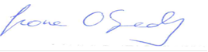  ____________________________________  Fiona O’Grady  CEO, Limerick Youth Service  Date: 26th June 2025 | 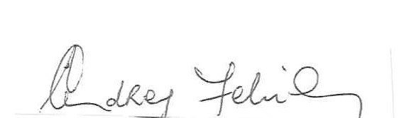  ____________________________________  Audrey Fehily  Chairperson, Limerick Youth Service  Date: 26th June 2025

For queries, please contact Sinead Noonan Relevant Person under the Children First Act 2015

Sinead Noonan
Limerick Youth Service,
Northside Youth Space,
Ballynanty Road,
Ballynanty Beg,
Limerick.
083-1736481

