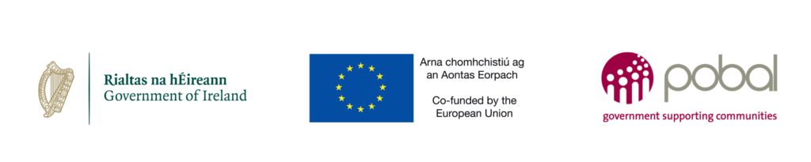
This project is co-funded by the Government of Ireland, through the Department of Social Protection, and the European Union

Limerick Youth Service WorkAbility: Inclusive Pathways to Employment Programme.

1. Eligibility

Are you aged between 16 and 25? Yes No

Verification of age, please choose one: Birth certificate Passport
Driving Licence
Do you live in Limerick City or surrounds? Yes No
Do you have a disability? Yes No
Please select all that apply (optional):

Mental Health Difficulty |  | Chronic illness |  | Learning disability
Neurodivergent |  | Intellectual disability |  | Other
Physical & Sensory disability |  | Sensory disability |  | Requested but not provided

Referral
Limerick Youth Service In receipt of a disability allowance/illness benefit
Referred by another organisation
Self Referral

(Proof of age will be required on registration and will be retained on file)
- Personal details and profile information
First name: ______________________ Surname: _______________________
Gender: Female Male Other Prefer not to say
Date of Birth: ______/______/______
Mobile number: _________________________
Address: _________________________________________________________________
__________________________________________________________________
3. Expectations of the

Referrer:
Young Person:

I, ___________________________________________ confirm that the information provided
to determine my eligibility for the WorkAbility Programme, is true and accurate to the best of my knowledge. I acknowledge the data controllers may process my personal details for the purpose of assessing my eligibility for the WorkAbility programme and to contact me directly with follow up correspondence.

Signed:__________________________________Date:__________________________
Legal Guardian consent for U18s:
Signed:_________________________________ Date:__________________________

