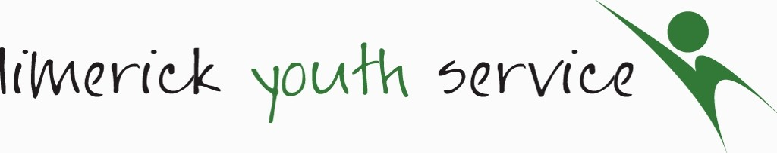

Job Description

BEWELL Rural Youth Mental Health Worker

Function: | The overall requirement of the role is to provide support for young people in terms of their mental health and wellbeing.  - Enhance the psychological, social and emotional wellbeing and resilience of the young people engaged.  - To reduce stigma in the area of mental health  - Strengthen young people’s participation in peer led education and mental health services/supports.
Location: | This post will be based in Limerick with outreach throughout County Limerick as required. Access to own transport with full clean driving license is essential.
Liaising with: | Referral agencies, Limerick Youth Service staff, volunteers, young people and parents
Reporting to: | Line Manager
Primary Duties and  Responsibilities | Young People  - Building trusting relationships with young people using the strengths-based approach of working coupled with evidence-based youth work methodologies.  - The outreach support will focus on; 1. Raising awareness of mental health and wellbeing with young people 2. Building confidence and resilience of engaged young people.  - The project will focus on those young people who are most excluded including ethnic and cultural minorities, young people with a disability, LGBTQ communities, young people experiencing social and economic disadvantage and vulnerable and at-risk young people.  - In addition, the outreach support will establish and mentor a project Youth Advisory Panel (YAP) so as to enable a youth-led peer approach to youth mental health and well-being.  - Facilitation of evidence based mental health programmes and offer a referral pathway to existing services if required e.g., counselling support. This will take part both in school setting and non formal settings eg LYS buildings .  - Working with young people to break down barriers to mental health through YAP engagement, programme delivery and involvement in national campaigns such as Green Ribbon Month and Mental Health Week.  - Responding appropriately and in a timely manner to crisis situations involving high risk behavior.  Communication & Facilitation  - Develop and maintain a professional relationship with young people in line with the Organisations policy on Safeguarding  - Encouraging and supporting young people to be active citizens and engage in conversations both local and national around Youth Mental Health.  - Raising awareness and reducing stigma around mental health through campaigns and events  - Delivery of Mind Out/Youth identity and other evidence informed programmes.  - Networking with Schools, Statutory and Community agencies in both Limerick City and County.  - Working closely with LYS Counsellors and Youth Workers  - Promoting positive choices for young people  Administration:  - Maintain accurate and confidential records in line with Data Protection  - Submit reports timely as required  Monitoring and Evaluation:  - Articulate project goals and demonstrate ability to monitor and evaluate the impact of the project through report writing and completion of assigned measurement tools e.g. outcome star, SDQs etc.  - Liaise and collaborate with funder on their conditions listed in service level agreement.  Other  - Actively participate in team meetings/other Limerick based fora to facilitate an integrated service delivery around mental health.  - Help inform best practice through sharing of information at meetings  - Attend training & supervision as required  - Comply with all organizational policies & procedures
Hours of Work | 35 hours per week to include evening and weekend work
Please Note: | The duties as outlined above are indicative of the main activities to be undertaken. They are not intended to be exhaustive. However, they may be subject to reasonable change in line with the future direction and changing needs of the organisation. None of these duties will be outside the capability of the worker.
Salary | Commensurate with experience

Limerick Youth Service reserves the right to reasonably alter the above criteria.

