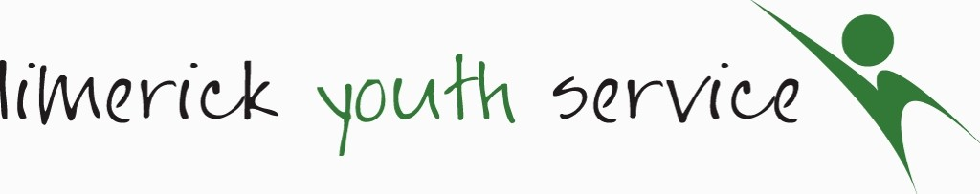
Psychotherapist
Job Description
Function: | Provide psychotherapy and other supports to young people in Limerick who present with mild to moderate behavioural and/or emotional issues
Location: | This post will be based in one of the Limerick Youth Service hubs with outreach throughout Limerick as appropriate.
Liaising with: | Referral agencies, Limerick Youth Service staff, volunteers, young people and parents
Reporting to: | Line Manager
Primary Duties and  Responsibilities | Young People:  - Provide a professional psychotherapy service to young people in Limerick City and county who present with mild to moderate behavioural and or/emotional issues.  - Provide young people presenting with psychological distress with the supports needed to fulfill their potential and cope with the challenges they face  - Build relationships with clients using the Limerick Youth Service Models of Therapy which is grounded in a Strengths based approach  - Be able to support young people who are involved in substance and alcohol misuse through evidence-based approaches.  - Identify those individuals who are at risk of immediate harm & require other sources of help and assist in engaging them in appropriate statutory services  - Refer young people as necessary in conjunction with the Organisations Safeguarding policy  - Support the individual to make positive choices in their life through evidence-based psychotherapy approaches including the strengths-based counselling approach as already listed.  - Provide evidence-based programmes to young people in group work settings  Communication  - Develop appropriate professional relationships with young people and parent/guardian  - Establish a relationship of trust and respect with individuals through a hybrid approach to deliver (online/face to face or both)  - Liaise and maintain appropriate contact with staff and external agencies as required to deliver effective responses in accordance with need.  - To attend and participate in meetings internal and external as may be required for the purpose of sharing and gathering information.  - Work in close collaboration with other BE WELL team members and ensure the provision of a wraparound service for young people  Record Keeping  - Maintain safe, accurate and up to date records and report as required.  - Be proficient in COREOM or other such psychological based tools.  - General computer literacy in packages such as office365 will be required.  General  - Adhere to all policies and procedures of the Organisation  - Partake in staff training & attend supervision as required.  - Carry out such other related tasks as may be assigned from time to time in consultation with Line Manager.
Hours of Work | 35 hours per week to include some evenings
Salary | Commensurate with experience:

Please note Limerick Youth Service reserves the right to reasonably alter the above criteria.

