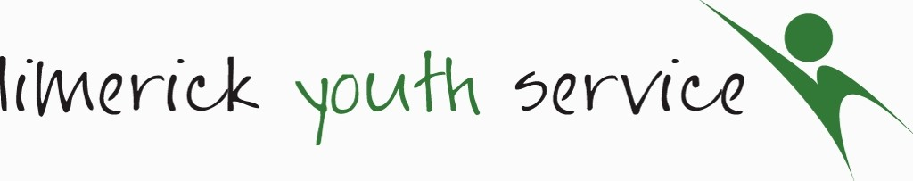
Limerick Youth Service (LYS) is required to record personal information on the young people that we work with including name and contact details, age, gender, nationality, educational and employment status and medical information. This is necessary in maintaining contact, for health and safety reasons, reporting to our funders and to ensure that our supports are relevant with the best possible outcomes for young people. We will collect this information on a ‘Registration and Consent Form’, which is then stored securely on paper format and on a computer data base for 7 years from when the young person leaves LYS.
For Office Use Only
Short Term Registration & Consent Form U 18s
Staff Member: Date: Project Area:
- CONTACT DETAILS
Young Person’s Name:
Parent/Guardian Details 1: | Name:  Address:  Mobile No.: Email Address:
Parent/Guardian Details 2: | Name:  Address:  Mobile No.: Email Address
Emergency Contact Details, if different from above:
- YOUNG PERSON’S PROFILE
Age Group: | 10-12 13-15 16-18
Gender: | Male Female Other Prefer not to say
- YOUNG PERSON’S MEDICAL INFORMATION: For safety reasons all participants must provide information of any underlying medical condition prior to joining. Any changes must be notified in writing.
GP Details: | Name: Phone Number:  Address:
Is there any reason why this young person should not take part in any physical activity or sport?  If YES, please give more detail: | Yes No
Please detail any medication that the above named young person may be required to carry or self-administer:
Does this young person suffer from anaphylactic shock? | Yes No
Please indicate if the young person has any special dietary requirements:

Declaration
I, confirm that the information provided above is true and accurate to the best of my knowledge.

PRINTED PARENT / GUARDIAN NAME:

Parent / Guardian Consent Form
To be completed by Parent / Guardian
(Please read each question and tick as appropriate)
Name of Young Person:

I give permission for the above named young person to participate in agreed weekly activities and/or programs and I accept that Limerick Youth Service has no responsibility for the young person outside of these agreed times*.
I understand that the named young person must abide by agreed rules and procedures and failure to do so could result in the young person missing out in planned activities or events.
In the event of an accident / illness requiring emergency treatment and failure to make contact with any of the persons listed on this form, I agree to give consent to the administration of treatment from a qualified medical practitioner.
In the event of a minor injury, I agree to give consent to the administration of first aid to the young person.
I give permission for the above named young person to participate in programme evaluation activities. These activities may include surveys and group discussions. This is to ensure a high quality service with positive impacts for young people. Participation is voluntary and data gathered is confidential.
I consent to the above named young person having their photograph taken or being filmed for the purpose of project publicity or reports to funders by Limerick Youth Service. | Yes No
I consent to the above named young person participating in digital youth work which will involve using online sites such as Zoom & others. These ‘online activity room’ will be administered by LYS staff | Yes No
*All activities and programmes are risk assessed and all venues are preapproved by Limerick Youth Service. Appropriate supervision is provided.
PARENT / GUARDIAN SIGNATURE: _____________

PRINTED PARENT / GUARDIAN NAME: _____________

DATE: _________________________________________

