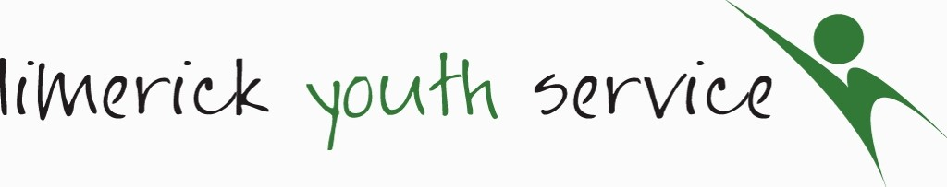
Limerick Youth Service (LYS) is required to record personal information on the young people that we work with including name and contact details, age, gender, nationality, educational and employment status and medical information. This is necessary in maintaining contact, for health and safety reasons, reporting to our funders and to ensure that our supports are relevant with the best possible outcomes for young people. We will collect this information on a ‘Registration and Consent Form’, which is then stored securely on paper format and on a computer data base for 7 years from when the young person leaves LYS.
For Office Use Only
Short Term Registration & Consent Form O 18s
Staff Member: Date: Project Area:
- CONTACT DETAILS
Name:
Contact Details : | Name:  Address:  Mobile No.: Email Address:
Emergency Contact Details: | Name:  Address:  Mobile No.: Email Address
Emergency Contact Details, if different from above:
- PROFILE
Age Group: | 18-20 21-24
Gender: | Male Female Other Prefer not to say
- MEDICAL INFORMATION: For safety reasons all participants must provide information of any underlying medical condition prior to joining. Any changes must be notified in writing.
GP Details: | Name: Phone Number:  Address:
Is there any reason why you should not take part in any physical activity or sport?  If YES, please give more detail: | Yes No
Please detail any medication that you may be required to carry or self-administer:
Does you suffer from anaphylactic shock? | Yes No
Please indicate if you have any special dietary requirements:

Declaration
I, confirm that the information provided above is true and accurate to the best of my knowledge.

PRINTED NAME:

Consent Form
(Please read each question and tick as appropriate)
Name:

I agree to participate in agreed weekly activities and/or programs and I accept that Limerick Youth Service has no responsibility outside of these agreed times*.
I understand that I must abide by agreed rules and procedures and failure to do so could result in my missing out on planned activities or events.
In the event of an accident / illness requiring emergency treatment and failure to make contact with any of the persons listed on this form, I agree to give consent to the administration of treatment from a qualified medical practitioner.
In the event of a minor injury, I agree to give consent to the administration of first aid.
I agree to participate in programme evaluation activities. These activities may include surveys and group discussions. This is to ensure a high quality service with positive impacts for young people. Participation is voluntary and data gathered is confidential.
I consent to having my photograph taken or being filmed for the purpose of project publicity or reports to funders by Limerick Youth Service. | Yes No
*All activities and programmes are risk assessed and all venues are preapproved by Limerick Youth Service. Appropriate supervision is provided.
SIGNATURE: __________________________________

PRINTED NAME: ___________________________

DATE: _________________________________________

