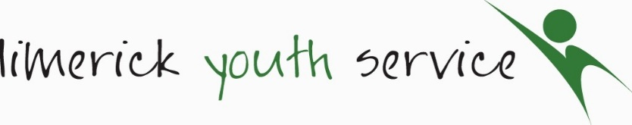
Long-Term Registration & Consent Form O 18s
For office use only

Staff Member: Date: ___________________

Project Area: ___________________
- CONTACT DETAILS
Name:
Contact Details : | Name:  Address:  Mobile No.: Email Address:
Emergency Contact Details: | Name:  Address:  Mobile No.: Email Address:
Emergency Contact Details, if different from above:
- PROFILE
Age Group: | 18-20 21-24
Gender: | Male Female Other Prefer not to say
Nationality:  If other, please state: | Irish Other
- Education/Employment Status
Are you currently attending:  If in education, please provide school/institution name & a brief address: | Secondary School Third Level  Other including Leaving Certificate Applied (LCA)  Not in Education (secondary, third level or LCA)
If not in education, please indicate employment/training status: | Employed  Unemployed  In further education/training (Includes LYS Community Training Centre - CTC, Youthreach)  Not in employment, education or training
- MEDICAL INFORMATION: For safety reasons all participants must provide information of any underlying medical condition prior to joining. Any changes must be notified in writing.
GP Details: | Name: Phone Number:  Address:
Is there any reason why you should not take part in any physical activity or sport?  If YES, please give more detail: | Yes No
Please detail any medication that you may be required to carry or self-administer:
Do you suffer from anaphylactic shock? | Yes No
Please indicate if you have any special dietary requirements:

Declaration
I, confirm that the information provided above is true and accurate to the best of my knowledge.

PRINTED NAME: DATE:__________________________________

Consent Form
(Please read each question and tick as appropriate)

Name of Young Person:

I agree to participate in agreed weekly activities and/or programs and I accept that Limerick Youth Service has no responsibility for me outside of these agreed times*.

I understand that I must abide by agreed rules and procedures and failure to do so could result in my missing out on planned activities or events.

In the event of an accident / illness requiring emergency treatment and failure to make contact with any of the persons listed on this form, I agree to give consent to the administration of treatment from a qualified medical practitioner.

In the event of a minor injury, I agree to give consent to the administration of first aid
I agree to participate in programme evaluation activities. These activities may include surveys and group discussions and will inform written reports/publications. This is to ensure a high quality service with positive impacts for young people. Participation is voluntary, data gathered is confidential and stored securely in line with General Data Protection Legislation (GDPR), 2017.
I consent to having my photograph taken and/or being filmed for the purpose of project publicity or reports to funders by Limerick Youth Service. | Yes No

* All activities and programmes are risk assessed and all venues are preapproved by Limerick Youth Service. Appropriate supervision is provided.

SIGNATURE: _____________

PRINT NAME: _____________

DATE: ______

