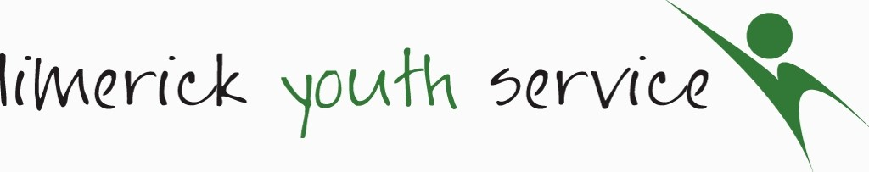
Individual Data Consent Form – Long Term Registrations (Over and Under 18s)
Limerick Youth Service (LYS) is required to record personal information on the young people that we work with including name and contact details, age, gender, nationality, educational and employment status and medical information. This is necessary in maintaining contact, for health and safety reasons, reporting to our funders and to ensure that our supports are relevant with the best possible outcomes for young people. We would also like to record information on ethnic/cultural background and on any additional physical, mental and learning support needs. This information is also known as ‘Sensitive Data’, which is voluntary and so does not have to be provided. We gather this information because we want to ensure that LYS is an equal, inclusive and diverse youth service and that our services and supports are tailored to the needs of young people.
We will collect this information on a ‘Registration and Consent Form’, which is then stored securely on paper format and on a computer data base for 7 years from when the young person leaves LYS. Young people may have additional support needs, which may benefit from more specific supports and/or referrals to organisations and agencies other than LYS. In these instances and ONLY with prior consent, the relevant information may be shared with these agencies.
Please be aware that under the Children's First Act 2015, we are obliged to report any concerns regarding child safeguarding to the relevant authority. Under the Irish Data Protection Acts and the EU General Data Protection Legislation (GDPR), 2016, you have a right to request a copy of personal information at any time. You can also withdraw your consent to provide any of the information required by LYS and to have the file deleted. You can do this by contacting Sinead Noonan at 061 412444 or sineadn@limerickyouthservice.org.
Data Consent | Signature
I give consent to record sensitive information relating to additional physical, mental or learning support needs and ethnic/cultural background:

PRINT PARENT/ GUARDIAN NAME:
PRINT YOUNG PERSON’S NAME (Under 18s):
OR
PRINT NAME (Over 18s):
DATE:
Sensitive Data
Ethnic/Cultural Background (using the Irish Census, 2016 categories): | White: Irish Irish Traveller Any other white background  Black or Black Irish: African Any other black background  Asian or Asian Irish: Chinese Any other Asian background  Roma  Other, including mixed background
ADDITIONAL SUPPORT NEEDS: Are there any additional learning, mental or physical support needs, which LYS should be aware of so as to provide a service tailored to the needs of all young people?

