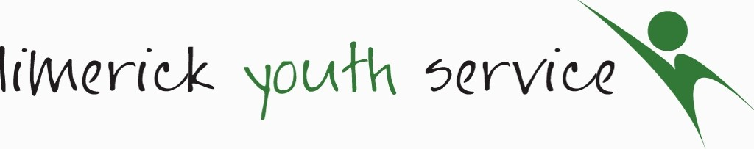

Child Safeguarding Statement

Name of service being provided: Limerick Youth Service founded in 1973 is a provider of youthwork, education, training and employability programmes and youth friendly spaces to young people aged 10-25 in Limerick City and County. We are a registered charity and a member of youthwork Ireland

Nature of service and principles to safeguard children from harm
Our Mission:
'Connecting with young people and supporting them to reach their full potential'

Limerick Youth Service provides a comprehensive range of youthwork activities and programs that support the social, emotional and physical well-being of young people.
We do this by providing the following youth work programmes and services:

Principles to Safeguard Children from Harm
Limerick Youth Service has a comprehensive list of policies, practices and activities that are committed to the following principles of best practice in Child Safeguarding and Welfare as laid out in Children First 2017.
- The safety and welfare of Children is everyone’s responsibility.
- The best interests of the child should be paramount.
- The overall aim in all dealings with children and their families is to intervene proportionately to support families to keep children safe from harm.
- Interventions by the state should build on existing strengths and protective factors in the family.
- Early intervention is key to getting better outcomes. Where it is necessary for the state to intervene to keep children safe, the minimum intervention necessary should be used.
- Children should only be separated from parents/guardians when alternative means of protecting them have been exhausted.
- Children have a right to be heard, listened to and taken seriously. Taking account of their age and understanding, they should be consulted and involved in all matters and decisions that may affect their lives.
- Parents/guardians have a right to respect and should be consulted and involved in matters that concern their family.
- A proper balance must be struck between protecting children and respecting the rights and needs of parents/guardians and families. Where there is conflict, the child’s welfare must come first.
- Child protection is a multiagency, multidisciplinary activity. Agencies and professionals must work together in the interests of children.

Risk Assessment
We have completed a risk assessment of the potential for harm to a child while availing of our services.
We are committed to mitigating the risk of harm to children while they are participating in the activities of the service. Below is a list of areas of identified risks and measures in place to manage these risks.
Risk Identified | Procedure in place to mitigate identified risk
1.  Young person alone with staff member. | - Lone Working policy  - Code of behaviour for staff.  - Safeguarding policy.  - Strict working ratios and supervision in place
2.  Physical Assault/Bullying (another young person, parent, guardian, adult volunteer, student, staff member or member of the public) | - Violence & Aggression Policy  - Disciplinary Policy & Procedures for staff & young people  - Respect & Dignity Policy & Procedures  - Clear procedure in place for raising complaints  - Code of Behaviour for staff & young people & students  - Staff trained in MAPA & Restorative Practice  - All staff, volunteers & students are Garda Vetted.  - Volunteer policy, Induction Training, Leadership Training.  - Induction for all young people & group contracts  - Incident reporting procedure in place  - CCTV Monitoring  - Group contracts in place
3.  A child or young person could be harmed if an unsuitable person was recruited as a staff member, volunteer, student on placement or external facilitator. | - Rigorous recruitment & screening policy & procedures  - Thorough application & declaration Form  - Interviewing & Reference Checks  - Garda Vetting & Garda Vetting Committee  - Induction to all policies & procedures  - Probationary period  - Safeguarding Training  - Ongoing supervision  - Staff & volunteer team meetings  - All events are adequately staff and supervised.
4.  Social Media - Cyberbullying, accessing inappropriate material. Targeted by inappropriate personnel. | - Code of behaviour & group contracts in place for children & young people around use of social media.  - Training & Information on Cyber Health and Education workshops  - Safeguarding policy in place and visible at activity level  - Clear Anti-Bullying Policy & Procedures in place  - Incident Reporting Policy & Procedures in place  - A complaints Policy & Procedure in place  - Stringent IT security measures in place  - Aware of rights and responsibilities.  - Mobile phone policy for Learners.
5.  Risk from public, visitors to any of the centres | - Sign in/out system in all premises  - Supervision Ratios maintained at all times  - CCTV monitoring in all premises
6.  Staff, Volunteers and / or students unaware or fail to respond to /or report a Child Safeguarding Concern. | - All staff/students/volunteers participate in Child Safeguarding Training.  - All Volunteers are made aware through Induction of what to do if they have a concern.  - Procedures are displayed and visible in all our premises and facilities we use. Individuals are aware of our Designated Liaison persons.  - Ongoing training and updating.
7.  Risk of young person coming to harm on Residentials/ Educational Trips or at an activity or event hosted by LYS. | - Risk Assessment completed ahead of any planned activity or trip. All venues are pre-approved and covered by Insurance.  - Drug & Alcohol policy for young people  - Supervision ratio adhered to.  - Staff & Volunteers bound by internal policies and procedures

Procedures
Our Child Safeguarding Statement has been developed in line with requirements under the Children First Act 2015, Children First: National Guidance for the Protection and Welfare of Children (2017), and Tusla’s Child Safeguarding: A Guide for Policy, Procedure and Practice. In addition to the procedures listed in our risk assessment, the following procedures support our intention to safeguard children while they are availing of our service:

- Procedure for the management of allegations of abuse or misconduct against workers/volunteers of a child availing of our service;
- Procedure for the safe recruitment and selection of workers and volunteers to work with children;
- Procedure for provision of and access to child safeguarding training and information, including the identification of the occurrence of harm;
- Procedure for the reporting of child protection or welfare concerns to Tusla;
- Procedure for maintaining a list of the persons (if any) in the relevant service who are mandated persons;
- Procedure for appointing a relevant person.

Implementation
We recognise that implementation is an on-going process. Our service is committed to the implementation of this Child Safeguarding Statement and the procedures that support our intention to keep children safe from harm while availing of our service.
This Child Safeguarding Statement will be reviewed by 11th March 2022, or as soon as practicable after there has been a material change in any matter to which the statement refers.

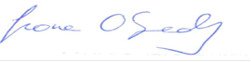  ____________________________________  Fiona O’Grady  CEO, Limerick Youth Service | ____________________________________  Patrick Lynch  Chairperson, Limerick Youth Service

For queries, please contact Sinead Noonan, Relevant Person under the Children First Act 2015

