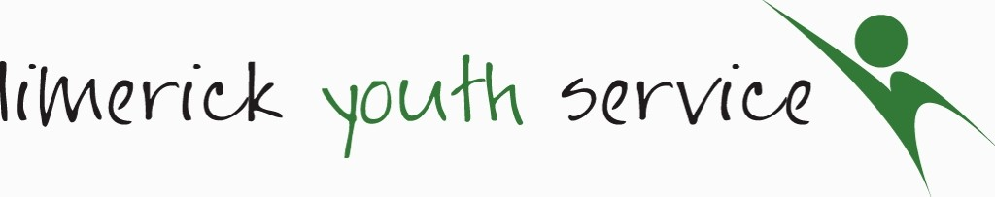
Individual Data Consent Form
Self-Referrals (Over 18s)

The Be Well Team: Youth Mental Health Service records information on the young people that we work with. We require personal information including name and contact details, age, gender, nationality, educational and employment status and medical information. This is necessary for contact, health and safety reasons, reporting to our funders and to ensure relevant supports with the best possible results. We would also like to record information on any additional physical, mental or learning support needs and on ethnic/cultural background. This information is known as ‘Sensitive Data’, which is voluntary, and so does not have to be provided. We gather this information so as to ensure that LYS provides an equal, inclusive and diverse youth mental health service. We collect this information on a ‘Referral Form’ and ‘Therapy Assessment Form’, which is then stored securely on paper format and on a computer data base for 7 years from when you leave LYS.

In cases where there exists additional support needs, more specific supports and/or referrals to organisations and agencies outside of LYS maybe beneficial. In these instances, and ONLY with your prior consent, the relevant information may be shared with these agencies. Please be aware that under the Children's First Act 2015, we are obliged to report any concerns regarding child safeguarding to the relevant authority. Under the Irish Data Protection Acts and the EU General Data Protection Legislation (GDPR), 2016, you have a right to request a copy of your personal information at any time. Your consent to provide any of the information required by LYS can be withdrawn at any time, or to have your file deleted. This can be done by contacting Sinead Noonan at 061 412444 or sineadn@limerickyouthservice.org.

Data Consent | Signature (Please X if submitting online, or provide signature if submitting in paper format)
I give consent to record sensitive information relating to additional physical, mental or learning support needs and ethnic/cultural background

PRINT NAME:

SIGNATURE:

DATE:

Limerick Youth Service – Be Well Team Self- Referral Form (Over 18s)
(Please fill in self-referral form and return; if assessment appointment not attended, this document will be shredded.)*
- Personal Details

Name:________________________Mobile No:_________________________Email:_____________________________
Address:_____________________________________________________________________________________________________________________________________________________________________________________________
Date of Birth: / / /
Gender: Male Female Other Prefer not to say
Nationality: Irish Other
If other, please state:
Preferred mode of contact: ☐Call ☐Email ☐SMS
☐Viber
☐Whatsapp
___________________________________________________________

Are you currently attending 3rd level education? YES No

Are you currently: Employed Unemployed In further education/training?
If employed, are you in: Full-time Employment Part-time Employment
2. Emergency Contact Details:

1: Name:_____________________Mobile No.___________________Email Address:_______________________________________

Address:_____________________________________________________________________________________________________

2: Name:_____________________Mobile No.___________________Email Address:_______________________________________

Address:_____________________________________________________________________________________________________
3. Details on additional agency/personnel involved, if any:

Social Worker: ________________________ Agency: ____________________ Tel. No. __________________
CAMHS: ______________________________ Contact: ____________________ Tel. No. __________________
GP / Doctor: __________________________ Surgery: ____________________ Tel. No. __________________
Garda: _______________________________ Station: ____________________ Tel. No. __________________
Drugs/Alcohol Worker: _________________ Agency: ____________________ Tel. No. __________________
Support Worker: ______________________ Service: ____________________ Tel. No. __________________

Medication details (if any):____________________________________________________________________________
Have you been recently been referred to another service? YES No
If yes, please give details: ________________________________________________________________________
Is referral currently on any waiting lists for other agencies? YES NO
Please name the agency/ies___________________________________________________________________________

4. Reason for self-referral:

5. Your Expectations:

Any other information that may be of support to application ( For example additional physical, mental, learning support needs; ethnic/cultural background):

Signed By:_________________________________________ Print Name:___________________________________

DATE: _______________________________________________
* This form will be basis for discussion on assessment date.

All referral forms to be emailed to: bewellteam@limerickyouthservice.org or posted to: Be Well Team, Limerick Youth Service, Northside Youth Space, Ballynanty Rd, Ballynanty, Limerick V94 TPP3
Any queries, please phone Siobhan O’Brien on 0863895031

