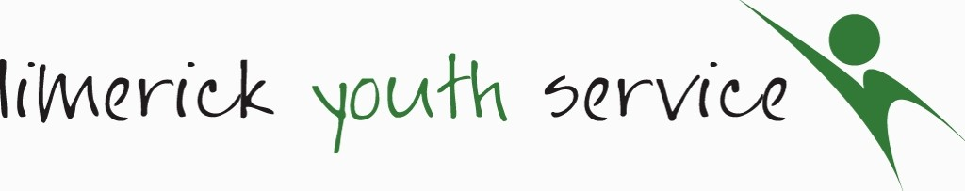
Individual Data Consent Form
For Parent/Guardian Referrals (Under 18s)

The Be Well Team: Youth Mental Health Service records information on the young people that we work with. We require personal information including name and contact details, age, gender, nationality, educational and employment status and medical information. This is necessary for contact, health and safety reasons, reporting to our funders and to ensure relevant supports with the best possible results. We would also like to record information on any additional physical, mental or learning support needs and on ethnic/cultural background. This information is known as ‘Sensitive Data’, which is voluntary, and so does not have to be provided. We gather this information so as to ensure that LYS provides an equal, inclusive and diverse youth mental health service. We collect this information on a ‘Referral Form’ and ‘Therapy Assessment Form’, which is then stored securely on paper format and on a computer data base for 7 years from when the young person leaves LYS.

The young person may have additional support needs, which could benefit from more specific supports and/or referrals to organisations and agencies outside of LYS. In these instances and ONLY with parent/guardian prior consent, the relevant information may be shared with these agencies. Please be aware that under the Children's First Act 2015, we are obliged to report any concerns regarding child safeguarding to the relevant authority. Under the Irish Data Protection Acts and the EU General Data Protection Legislation (GDPR), 2016, you have a right to request a copy under/over 18s personal information at any time. Your consent to provide any of the information required by LYS can be withdrawn at any time, or to have the young person’s file deleted. This can be done by contacting Sinead Noonan at 061 412444 or sineadn@limerickyouthservice.org.

Data Consent | Signature (Please X if submitting online, or provide signature if submitting in paper format)
I give consent to record sensitive information relating to additional physical, mental or learning support needs and ethnic/cultural background

PRINT UNDER YOUNG PERSONS NAME:

PARENT/GUARDIAN SIGNATURE:

DATE:

Limerick Youth Service – Be Well Team Parent/Guardian Referral Form
(Please fill in referral form and return; if assessment appointment not attended, this document will be shredded.)*

Consent for under 18’s is required (Age remit for team is age 14-25)
Is the young person aware of the referral? ☐Yes ☐No
Preferred mode of contact: ☐Call ☐Email ☐SMS
☐Viber
☐Whatsapp
1. Family Contact Details:

Parent/Guardian Details 1: Name:_____________________Mobile No.:___________________Email:_______________

Address: ___________________________________________________________________________________________

Parent/Guardian Details 2: Name:_____________________Mobile No.___________________Email:________________

Address:___________________________________________________________________________________________

Emergency Contact Details if different from above:________________________________________________________
__________________________________________________________________________________________________
2. Young Person’s Details

Name: ____________________________________________________________________________________________
Date of Birth: / / /
Gender: Male Female Other Prefer not to say
Nationality: Irish Other
If other, please state:
_________________________________________________________

Is the young person is attending 2nd level? YES NO
If yes, please provide a school name and brief address: __________________________________________________________________________________________________
Is the young person currently: Employed Unemployed In further education/training?
3. Details on additional agency/personnel Involved, if any, with young person/family:

Social Worker: ________________________ Agency: ____________________ Tel. No. __________________
CAMHS: ______________________________ Contact: ____________________ Tel. No. __________________
GP / Doctor: __________________________ Surgery: ____________________ Tel. No. __________________
Garda: _______________________________ Station: ____________________ Tel. No. __________________
Drugs/Alcohol Worker: _________________ Agency: ____________________ Tel. No. __________________
Support Worker: ______________________ Service: ____________________ Tel. No. __________________
Medication details (if any):____________________________________________________________________________
Has young person/family recently been referred to another service? YES NO
If yes, please give details:
Is referral currently on any waiting lists for other agencies? YES NO
Please name the agency/ies___________________________________________________________________________

4. Reason for referral of young person:

5. Expectations of:

Young Person:
Parent/Guardian:
Any other information that may be of support to application ( For example additional physical, mental, learning support needs; ethnic/cultural background)

Signed By: _______________________________________ Print Name:_________________________________
(Parent/Guardian)

Date:_______________________________

* This form will be basis for discussion on assessment date
All referral forms to be emailed to: bewellteam@limerickyouthservice.org or posted to: Be Well Team, Limerick Youth Service, Northside Youth Space, Ballynanty Rd, Ballynanty, Limerick V94 TPP3
Any queries, please phone Siobhan O’Brien on 0863895031

